**POWER BI PROJECT TASKS**

**Learners have to develop a Report to support the answers to the following questions and suggestions.**

**Objective Questions:**

1. In analyzing the hospital dataset with Power BI, ensure data cleaning to address inconsistencies and missing values before further analysis.

**Ans:-** The data provided by the Newton school is organized and is in the structure format and no further cleaning is required on the data but in **Hospital ER** table the patient_sat_score has some null value that are replace by the 0 because the these are null because patients doesn’t rated.

1. **Assess the Average Waiting Time:** Analyse the patient wait times to identify the average duration a patient spends before receiving care.

**Ans:-** The analysis of the patients wait time can be easily obtain by using one of the DAX function that is **=AVERAGE()**

**DAX FORMULA :** Avg.waiting time = AVERAGE(‘Hospital ER’[patient_waittime])

1. **Visits by Department Referral:** Calculate the total number of visits to each department based on referrals to understand which departments are most frequently visited.

**Ans:-** Total number of visits to each department based on referrals can be easily understand by the using a table chart that contains different dept.name and the total patients counts to the particular department.

**TOTAL PATIENTS = 9216**

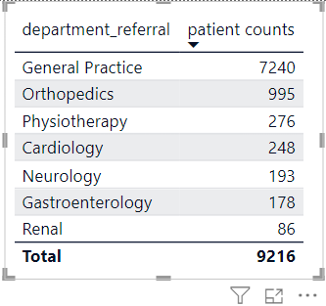

By analysing the this table chart we can easily get to know that **General Practice**  has more numbers of patients count(7420) and **Renal** has lowest number of patients counts(86).

1. **Patient Visits by Age Group:** Segregate patient visits according to different age groups to see which demographics utilize healthcare services the most.

**Ans:-** Segregate patient visits according to different age groups to see which demographics utilize healthcare services the most, to obtain or to extract the data I have grouped the patients into mainly 3 different categories which are Young(0-30),Elder(30-60),old(60-above).

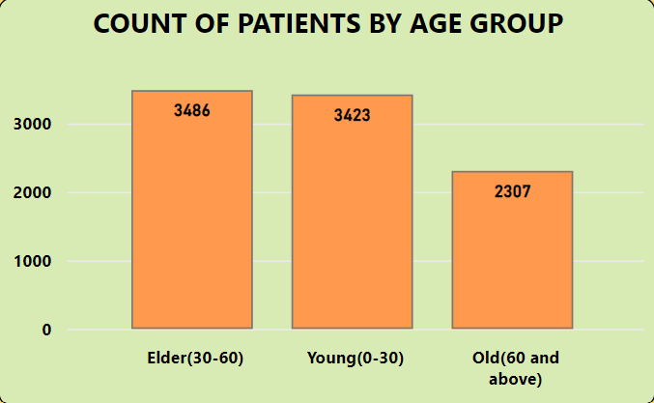

By analysing the chart we can easily get t know about the which age group uses the services like age group 30 – 60 means Elder has utilize the hospital services more.

1. Were there any Null values in the data? What would be the best way to handle these Null values and which approach have you opted for?

**Ans:-** There are many approaches to handle null value in any data set like if the format of the columns is numeric then then the null values can be replace by the ‘0’ and If the format is string then we can simply write ‘not available’ or ‘null’. The data set I get from Newton School contains null value in the Hospital ER table in columns name patient_sat_score so I replace the null value with 0.

1. Is there any relation between the number of visits and the Gender of the patients?

**Ans:-** There is a relation between number of visits and the gender of the patients by analysis we get to know that count of female patients is more than the count of male patients and some patients do not disclose there gender.

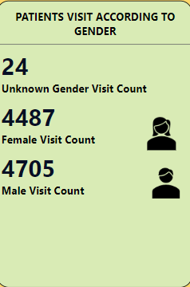

1. Average Satisfaction by Demographics: Determine the relationship between patient satisfaction scores, their age groups, and racial backgrounds to pinpoint areas for improvement in patient experience.

**Ans:-** The relationship between patient satisfaction scores, their age groups, and racial backgrounds, by analysing the chart we can easily get that young age group(0-30) is more satisfied age group and relation based on race then pacific Islanders race is more satified by the hospital services.

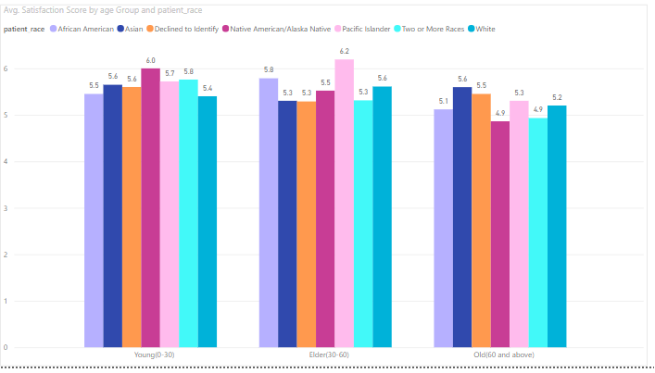

1. The hospital's managing director seeks to evaluate the revenue of each department to understand how much revenue is generated by each.

**Ans:-** Hospital's managing director can easily get the revenue generated by each department by just seeing the table chart given below.

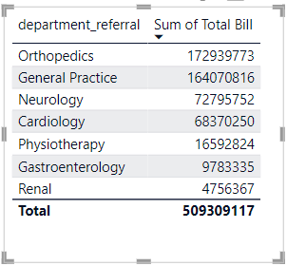

1. Which department is charging the highest appointment fees in general? Use an aggregation DAX function to solve this question.

**Ans:-** **Neurology Department** is charging the highest appointment fee in general.

**DAX FORMULA :** High fee charged by department = CALCULATE(

VALUES('Hospital ER'[department_referral]),

FILTER(ALL('Hospital ER'[department_referral]),

CALCULATE(MAX(Doctor[Appointment Fees]),

'Hospital ER'[department_referral] = EARLIER('Hospital ER'[department_referral])

) = MAX('Doctor'[Appointment Fees])))

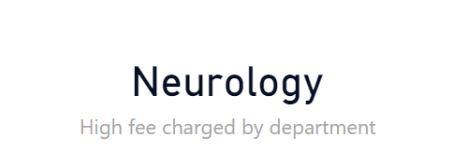

1. Create a tabular visualization in the Report view which consists of Month-wise total visits in the hospital.  Add a third column in the table that consists of the previous month’s total visits for each month’s row. Also, include a column that states whether the visits in a month are greater than that of the previous month's visits.

**Ans:-**

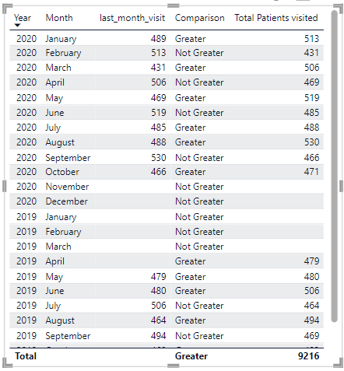

1. Using ‘Calculate’ and a row iteration DAX function calculate the total number of patients who have visited Dr. Smith.

**Ans:-** Total number of patients visited or total number of patients attended by Dr. Smith are 5986.

**DAX FORMULA :** patients_attended_by_Dr. Smith = CALCULATE(COUNTX(Doctor, Doctor[patient_id]),Doctor[Doctor Name]="Dr. Smith")

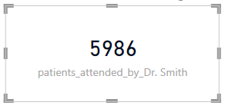

1. Calculate the average age of the patients who visit the Orthopedics department. Will the approach used to calculate this metric be different if the requirement had been all departments’ average age?

**Ans:-** We can easily calculate this using AverageX function of power bi

**DAX FROMULA:**

Orthopedics patients avg. age = CALCULATE (AVERAGEX ('Hospital ER','Hospital ER'[patient_age]),'Hospital ER'[department_referral] = "Orthopedics")

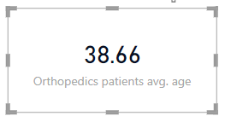

1. Were there any data format issues in the data, and if there were/are how you handle them?

**Ans:-**In power bi using power query editor we handle missing values, inconsistencies, standard formatting, conversions. The data set provided by the Newton school has some inconsistencies like null value.

Using power query editor I split the date and time column separately so that I can use them separately according to the condition.

1. When we add a column in Power Query what’s the code that comes in M language in the formula bar? What do you know about M-query?

**Ans:-** M-query (Power Query formula language) is for data transformation in Power BI. It lets you connect, clean, and shape your data. Think of it as a workbench with tools for adding/removing columns, formatting, and calculations. While Power Query offers a user-friendly interface, M-query provides the underlying code for more control.

**=Table.AddColumn(#"PreviousStepName","NewColumnName", each [Column1])**

=Table.AddColumn : This function is the workhorse for adding columns in M.

#"PreviousStepName" : This represents the name of the table you're working on after the previous transformation step.

"NewColumnName" : This is the name you're giving to the new column you're adding.

each [Column1] : This part defines what values will go into the new column. In this case, each instructs M to perform the following for each row:

[Column1] instructs M to take the value from the existing column named "Column1"

**Subjective Questions**

1. What is the relation between patient wait time and satisfaction scores?

**Ans:-** The relation between the patient waiting time and the patient satisfaction score can be analysis using the different charts here I use the line chart that give the insight that when the patient waiting time is more the satisfaction score is lowest and when patient waiting time is less score is high.

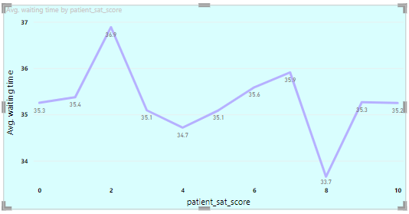

1. How do patient demographics affect the frequency of visits to different departments?

**Ans:-** To about the how do the patients demographics affects the frequency of visit to different department i plot the cluster column chart from that we can easily analysis the most visited race or frequency of the visit is high for race is **white** and less frequency of visit for race is **native American / Alaska native.**

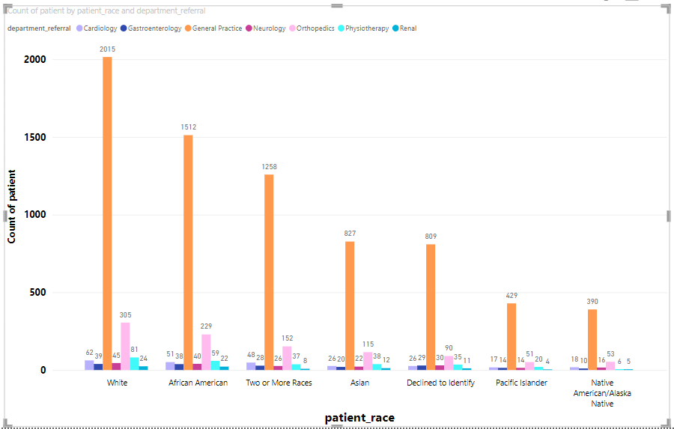

1. Is there a noticeable trend in the volume of patient visits throughout the year?

**Ans:-** to understand weather there is any trend in patients visit based on the year I use area chart I found there is a noticeable trend in the volume of patient visits throughout the year from 2019 to 2020 and the trend is positive means the count of patients visits increased.

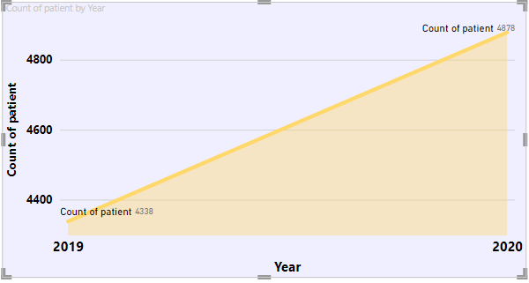

1. Which age groups report the highest and lowest satisfaction scores?

**Ans:-** Highest and the lowest satisfaction score according to the age group can be analysis by analysing the chart

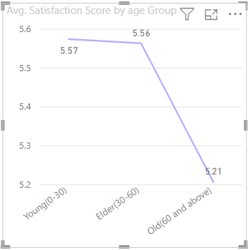

Young age group (0-30) has highest satisfaction score and old(60 and above ) has lowest satisfaction score.

1. Say someone outside of the hospital claims that there is racial or gender-based discrimination in the hospital, how will you identify whether the claim was right or not?

**Ans:-** The claim that someone from outside made that there is racial or gender based discrimination in the hospital is pretty much right, there is discrimination but not that high.

I made this statement by analysis this charts like native people had to wait for long time than the other races and in the patients who doesn’t disclose their gender also wait for long time.

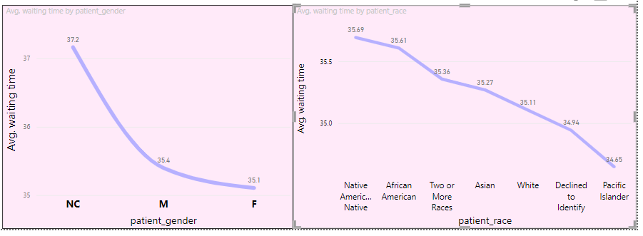

1. The hospital management intends to offer discounts to patients. How should these offers/discounts be assigned to patients, on what basis, and why?

**Ans:-** The hospital management intends to offer discounts to patients this offers must provided to the patients who visited to neurology and cardiology department because these two departments charges more fee as compare to other departments.

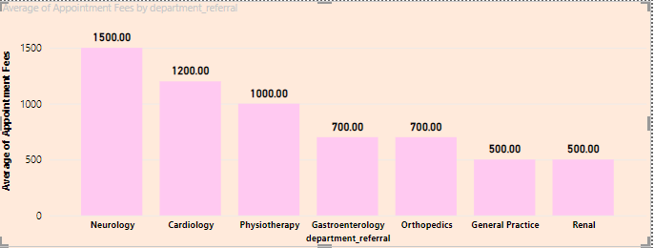

1. The hospital has a budget to hire 2-3 new doctors. They have asked for your suggestions on which departments they should hire.

**Ans:-** If the hospital has the budget to hire 2-3 new doctors so we must analysis which department has highest count of patients visits and number of doctors assign to that particular department.

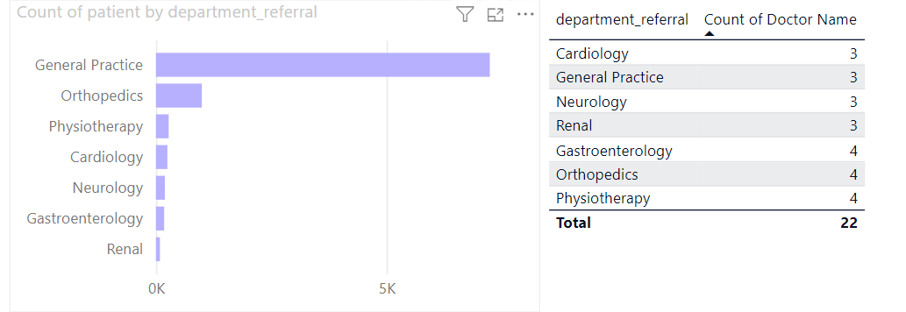

By analysing the chart and table we can draw a conclusion that we must hire new doctors for **General Practice** department because it has more number of patients that count of doctors are also less.

1. Is the hospital profitable? How will you determine the profitability?

**Ans:-** To check weather is hospital is profitable or not we can just check for sum appointment fee and total revenue generated like

**Total revenue Generated($50,93,09,117) –** **Sum Appointment fee($53,47,200)**

**Total profit of hospital : $503,961,917**

Hence we can conclude that the hospital is profitable.

1. Any Department for which the waiting time is oddly large?

**Ans:-** By analysing the below chart we can easily get that departments neurology and physiotherapy has little bit more waiting time as compare to other department

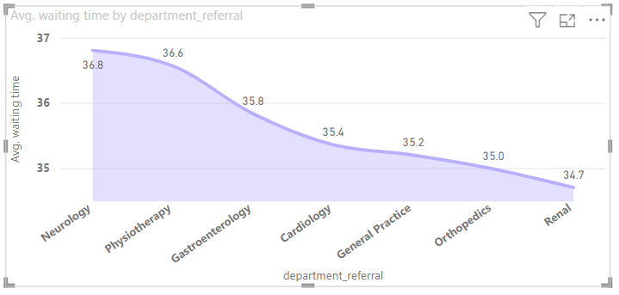

1. Come up with strategies to provide discounts to the patients.

**Ans:-** Some of the Strategies are :

Bulk Discounts: Offer discounts for patients who purchase multiple appointments or services in advance. For example, offer a package deal for a set number of appointments or treatments at a reduced rate.

Membership Programs: Implement a membership program where patients pay a monthly or annual fee in exchange for discounted rates on services. This can encourage loyalty and repeat business.

Referral Discounts: Encourage patients to refer friends and family by offering them a discount on their next visit for each successful referral. This not only incentivizes referrals but also helps expand your patient base.

Seasonal Promotions: Run promotions during slower seasons or holidays to attract patients during typically quiet times. Offer special discounts or packages tied to specific holidays or events.

Special Offers for New Patients: Offer a discount for new patients to encourage them to try your services. This can help attract new business and give patients a chance to experience your practice.

Senior or Student Discounts: Provide discounted rates for seniors or students. This can help make your services more accessible to these demographics and build goodwill within the community.

Insurance Negotiation: Negotiate with insurance providers to offer discounted rates for patients covered under certain plans. This can help make your services more affordable for a wider range of patients.

Community Outreach Events: Host community events or health fairs where you offer discounted services or consultations. This not only promotes your practice but also provides a valuable service to the community.

Bundle Services: Offer discounts for patients who bundle multiple services together. For example, offer a discount for patients who get both a dental cleaning and whitening treatment during the same visit.

1. Say you need to align the doctors of the “General Practice” department to work in one of the two shifts, how will you identify what will these two shifts' timings be, and how will you divide the doctors in these two shifts? And also will this 2 shift policy be helpful for the hospital?

**Ans:-** According to all the analysis we come at a point that general practice department has only 3 doctors named as Dr.Johnson,Dr.Smith,Dr.Williams and among these Dr.Smith has excellent performance from doctors dashboard so at AM Dr.Smith will attend all the patients and At PM Dr.Johnson and Dr.Williams attend all patients.

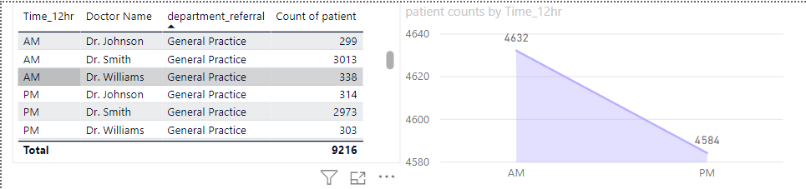

1. What do you understand by PowerBI gateway? What are its use cases?

**Ans:-**

Power BI Gateway is a tool provided by Microsoft as part of its Power BI suite of business analytics tools. It allows users to connect on-premises data sources to the Power BI service in the cloud. The Power BI Gateway acts as a bridge between on-premises data sources and the cloud-based Power BI service, enabling secure data transfer and real-time data access.

Use cases of Power BI Gateway include:

Connecting to On-Premises Data Sources: Power BI Gateway enables organizations to connect to their on-premises data sources such as SQL Server databases, SharePoint lists, Excel files, and more, and securely transfer data to the Power BI service for analysis and visualization.

Real-Time Data Refresh: With Power BI Gateway, users can set up real-time data refresh for on-premises data sources. This ensures that reports and dashboards in Power BI reflect the most up-to-date information from on-premises systems.

Scheduled Data Refresh: Power BI Gateway allows users to schedule data refreshes at regular intervals for on-premises data sources. This ensures that reports and dashboards are always refreshed with the latest data without manual intervention.

DirectQuery: Power BI Gateway supports DirectQuery mode, which allows users to query large volumes of data in real-time directly from on-premises data sources without importing the data into Power BI. This is useful for scenarios where data freshness is critical, and users need access to real-time data.

Data Security and Compliance: Power BI Gateway ensures secure data transfer between on-premises data sources and the Power BI service by encrypting data in transit and enforcing data access policies. This helps organizations maintain data security and compliance with regulatory requirements.

Hybrid Deployment: Power BI Gateway enables organizations to implement hybrid deployment models, where some data remains on-premises while other data is stored in the cloud. This provides flexibility and scalability in managing and analyzing data across different environments.

1. How would you approach this problem, if the objective and subjective questions weren't given?

**Ans:-**

* Clearly define the objectives and scope of the "Columbia Asia" project to understand what insights are needed from the hospital management system.
* Perform thorough data cleaning, transformation, and modeling to ensure the data is accurate and ready for analysis.
* Develop a comprehensive data model in Power BI that accurately represents the relationships between different data entities within the hospital management system.
* Design and create interactive reports and dashboards in Power BI to visually represent the data and address the key questions identified during project scoping.
* Utilize a variety of Power BI visualizations such as charts, graphs, and tables to effectively communicate insights from the data.
* Incorporate interactive features like slicers, filters, and drill-downs to enable users to dynamically explore the data and gain deeper insights.
* Ensure that the solution is user-friendly and intuitive, allowing stakeholders to easily navigate and interact with the reports and dashboards.
* By following this approach, provide stakeholders with a powerful tool to gain valuable insights from the hospital management system data, enabling informed decision-making and improved operational efficiency.

1. Can you analyze and write the type of relationship between the doctor id and department, is it one-to-one?

**Ans:-** write the type of relationship between the doctor id and department is **many to many**

Because one department can have many doctors and one doctor can handle multiple departments

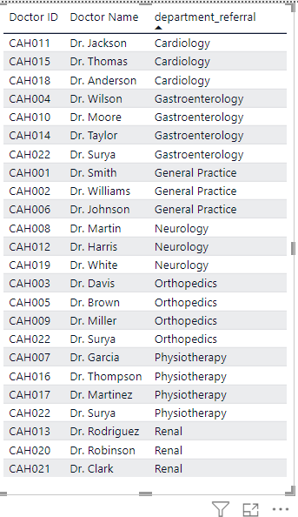

Like from the above table we can easily get that Dr.Surya is attending three different departments. So the relation between doctors and departments is many to many cardinality.

**Report**

The hospital has asked for a report with three tabs:

* Main Tab
* Doctors’ Tab
* Patients’ Tab

* **Using the Main tab in the report,** the hospital should be able to look at the overall metrics like the number of daily visits, revenue produced on that day, customer satisfaction, how busy are different departments on that day, and general waiting time on that day. This tab should have a slicer of date.

* **Using the Doctors’ Tab,** the Chief Of Staff at the hospital should be able to look at the individual doctor’s performance metrics like customer satisfaction, the number of patients he was visited by, the revenue he has generated, and his appointment fees. This tab should have a slicer of the Doctor's Name or ID.

* **Using the Patients’ Tab,** the Patient’s Care Chief at the hospital wants to look at a customer’s profile which would involve metrics like the most frequently visited department, their age, their race, their waiting time, number of visits, the total amount that they have paid to the hospital, etc. All the metrics using which they can address the patient very carefully in their visits. This tab should have a slicer of the Patient's Name or ID.

**Make sure that all the visualizations look decent and are placed in a proper order. Each tab has different POCs (Point Of Contact), so make sure you involve all the metrics that POC may look at in that tab along with those mentioned in the tab description.**

**After making the report on the Desktop ensure that it is hosted on PowerBI service and use the hosted link for submission of the dashboard and mentioning on the resume.**